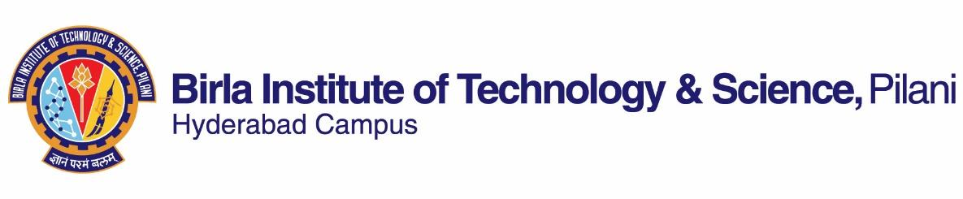

**FIRST SEMESTER 2023-2024**

Course Handout-Part-II

Date: 11-08-2023

In addition to Part-I (General Handout for all courses appended to the timetable), this portion gives further specific details regarding the course.

*Course No*. : HSS F338

*Course Title* :Comparative Indian Literature

*Instructor-in-charge* : Prof. T. Vijay Kumar

**Scope and Objective of the Course:**

This course aims to give students a holistic view of Indian literature through a comparative study of selected texts from Indian languages, including English. Texts drawn from different languages, cultures, and mediums will be compared and contrasted in order to gain an understanding of the relationship among texts, and between content and form, text and context. What is literature and what distinguishes a literary text from others? What is comparative literature, and what, how, and why do we compare and what is gained by such an exercise? What is Indian literature and what makes it Indian? These are some of the related questions, among others, that will be explored in the course. While the students will be introduced to a wide variety of texts, the underlying objective is to make them perceptive readers and empathetic human beings capable of recognizing and respecting difference. Students will be encouraged to read texts closely and relate them to their lived experiences so as to help them appreciate the relationship between life and literature.

**Textbook**

1. *Comparative Literature: A Very Short Introduction* by Ben Hutchinson, OUP, 2018.

**Reference Books**

1. Bassnett, Susan. *Comparative Literature: A Critical Introduction*. OUP, 1992.
2. Dev, Amiya and Sisir Kumar Das, eds. *Comparative Literature: Theory and Practice*. Allied Publishers, 1989.
3. Dev Sen, Nabaneeta, ed. *Counterpoints: Essays in Comparative Literature.* Prajñā, 1985.
4. Panicker, K. Ayyappa. *Spotlight on Comparative Indian Literature*. Papyrus, 1992.
5. Totosy De Zepetnek, Steven & Tutun Mukherjee, eds. *Comparative Literature, World Literatures, and Comparative Cultural Studies.* Foundation Books, 2013.

NOTE: Text and reference books listed above will be supplemented, if and when needed, with other resources in the classroom. Students are expected to be familiar with the additional reading material as well.

**Course Plan:**

|  |  |  |  |
| --- | --- | --- | --- |
| **Lecture No.** | **Learning Objectives** | **Topics to be Covered** | **Chapter in the Text Book** |
| 1-6  Unit I | Introduction to literature; Introduction to comparative literature | Terms, Concepts, Genres; Meaning, Definition, Scope | Class notes; TB-1 |
| 7-17  Unit II | Introduction to the study of  comparative literature | Method and history of comparative literature; Sisir Kumar Das: “Comparative Literature in India: A Historical Perspective”; Selected texts for comparative study | TB-2; TB-3; The texts |
| 18 | Recap of Unit I and II | | |
| 19-29  Unit III | Introduction to Indian literature, World Literature, and Translation | National literature and world literature; Translation and transformation; Rabindranath Tagore: “Visva Sahitya”; Selected texts for comparative study | TB-4; The texts |
| 30-39  Unit IV | Introduction to comparative frames of reading | David Damrosch: “Comparative Literature?”; Selected texts from Indian and world literature for comparative study | The texts |
| 40 | Recap of Unit I-IV | | |

**Evaluation Scheme:**

|  |  |  |  |  |
| --- | --- | --- | --- | --- |
| **Component** | **Duration** | **Weightage (%)** | **Date & Time** | **Nature of Component** |
| Assignment  1 & 2 | TBA | 15 & 15 | TBA | Open Book |
| Mid-semester Test | 90 Minutes | 30 | 13/10 - 9.30 - 11.00AM | Closed Book |
| Comprehensive Examination | 3 hours | 40 | 18/12 FN | Closed Book |

**Chamber Consultation hours:** In K-128; Wednesday—11:30-12:30.

**Notices:** If any, will be posted on CMS.

**Make-up Policy:** Assignments will not berepeated.Make-up for other assessment components will be allowed only in genuine cases and on the basis of verifiable, documentary proof.

**Academic Honesty and Integrity Policy:** Academic honesty and integrity are to be maintained by all the students throughout the semester and no type of academic dishonesty is acceptable.

T Vijay Kumar

**INSTRUCTOR-IN-CHARGE**